# Technology

Help: To detail the relevant aspects of the project, the following information may be helpful, though not all will always apply:  
- A drawing of the **existing** architecture of a system or the **existing** process (we are not talking about the solution yet). If drawing a process or overlaying a process to an architecture, number the steps of the process. Decide and clearly state whether the drawing represents a process or a system.  
- Which other systems (non-human actors) are involved?  
- Which persons (human actors) are involved?  
- How is the current system used? Which tasks/functions are the persons or other systems trying to execute? For which purpose?  
- How do they interact with the system?  
- Which data flow between the system and the actors? Purpose, format, size, performance constraints, frequency etc.?   
  
Give enough contexts and explain all acronyms so that somebody not already involved in the project can understand what is going on. Point out the “problem“ areas. Don‘t use marketing language.  
  
UML (Unified Modeling Language) is a set of standard formalisms (use case diagrams, message sequence charts, activity diagrams, object diagrams, etc.) to describe processes and software, and thus the preferred means of description. (UML Tutorial: <http://odl-skopje.etf.ukim.edu.mk/uml-help/>)  
In other cases conventional diagrams will suffice.

Figure 1 displays the monitoring system block diagram for this project. Images are received through the image acquisition system (i.e. camera). Prior to, and during operation, the camera parameters are characterized through the calibration module. The image processing block takes the raw images obtained by the camera and converts them (digitalization process) to a format suitable for storage and post-processing. The database store the information related to the image and instrument and communicate with a server. Cloud and irradiance function blocks perform the algorithms required to estimate and forecast the future irradiance levels. The system can also interface with an external block such as Nereo for better irradiance estimation. The output of the monitoring system serves as input for a PV/Battery controller

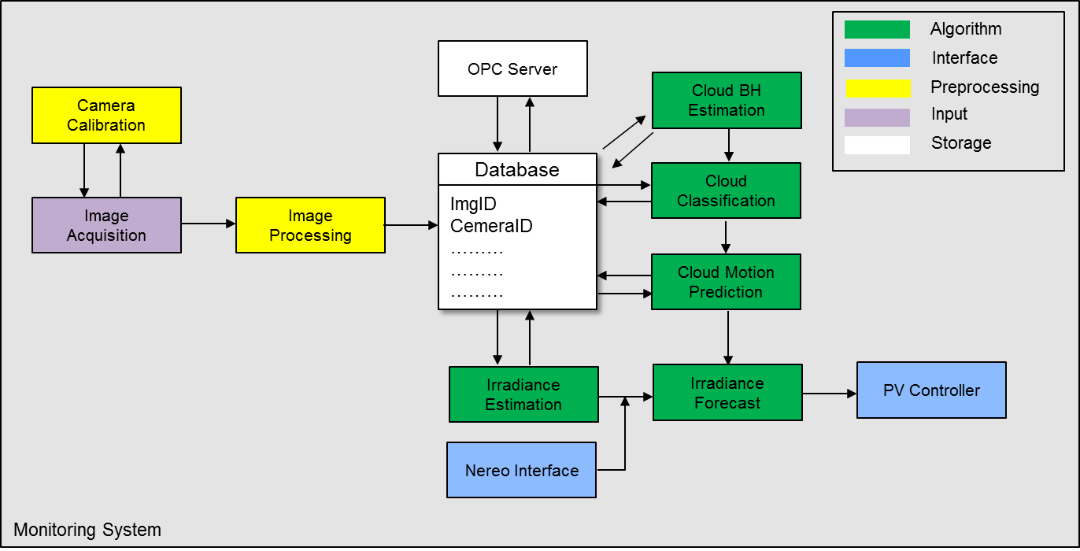

Figure 1 VISMO System Architecture

Next a summary of the functionality of each block is presented.

*Camera Calibration:*

The objective of this module is to identify the true parameters of the camera that produce a photograph that meets the minimum requirements for analysis. Camera characteristics include exposure times, gain and offset, focal length, image format and principal point.

*Image Acquisition*

This module adjusts the parameters that carry out the image acquisition. Two important aspects that this module controls are:

- Timer. It sets the time to take pictures with the specified interval during day time. Short time interval (5min) can represent a compromise between shot interval and storage capacity.)

- Decision whether or not images with solar zenithal angles less than or equal of 80° should be stored in the database.

*Image Processing*

The objective of this module is to pre-process the raw images so that any object present, such as solar occultor and/or birds are discarded from the images. This is normally accomplished by applying masks to the raw images. The masks are matrices with binary elements corresponding to the location of the object in the image. The element values are used to indicate the true or false pixel values. Regions indicated as true are part of the region of interest (ROI) and only these pixels are used in the cloud decision and forecasting exercises.

*Database*

The database has the purpose of storing the images recoded by the image acquisition system.

*Cloud Base Height (CBH) Estimation*

The CBH estimation module computes the CBH using information stored in the image files and considering the calibration parameters of each camera. The module applies stereovision calculations to identify the same cloud feature in an overlapping area of two or more images. Once the features have been identified, the module computes the angles relative to the camera axis required for the CBH calculation.

*Cloud Classification*

The cloud classification module implements the classification algorithms. The objective is to classify the cloud type identified (if any) in each of the stored images by identifying common features among the images. Features that are sought in this module correspond to spectral, textual, contextual and/or physical features.

*Cloud Motion Prediction*

The cloud motion prediction module implements the algorithms required for cloud velocity and direction of motion estimation. Once the cloud velocity field (velocity and direction) is identified the module proceeds to perform cloud forecasting by correlating two consecutive images at time t0 and t0-dt.

*Irradiance estimation and forecasting*

The irradiance estimation and forecasting modules implement the algorithms required for predicting solar irradiance levels.

## User Operations

Help: Show important relations between actors and the system with e.g. Use Cases.

Figure 2 shows the contribution of VISMO to an advanced controller for a PV/Battery system.

The control system involves two types of controller one fast process controller and one not-so-fast controller (Model Predictive Controller – MPC). While the process control provides optimal control inputs in the order of seconds, the MPC controller provides optimal set points the order of minutes. For the operation of the MPC controller, an accurate model describing the system is required. This is accomplished by providing accurate input parameters to the model. Input model parameters include: power generation, load profile, battery state of charge (SOC), electricity prices and weather forecast (i.e. solar irradiance). It is in the latter, where VISMO can make a contribution to improve the control system. Reliable (more accurate) irradiance estimation obtained with a VISMO system can provide more accurate model predictions and thus improve the operation the PV/Battery system.

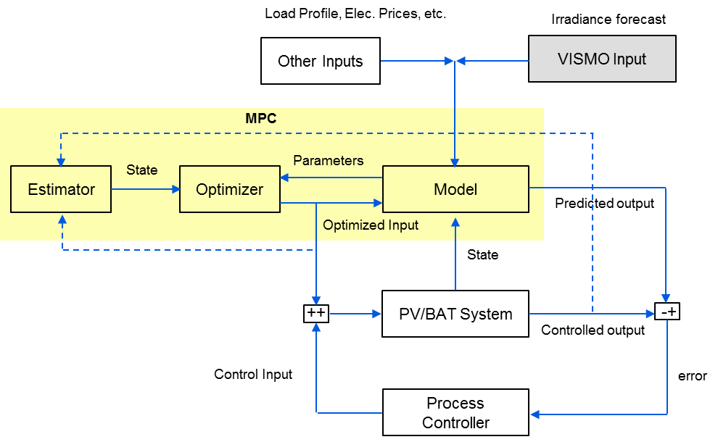

Figure 2 Contribution of VISMO system to the advanced control of PV/Battery Systems

## Implementation Approach

Help: Software/hardware platform(s) to be used.  
Which existing components are to be used and how?  
Which third party components/tools are to be integrated?  
Give a picture of system architecture and main components.

The algorithms required for the operation of the VISMO prototype will implemented in MATLAB with some C++ libraries interfaced via MEX files.

Figure 3 shows main components of the VISMO prototype. Refer to Section 3 for a functional description of each of the components.

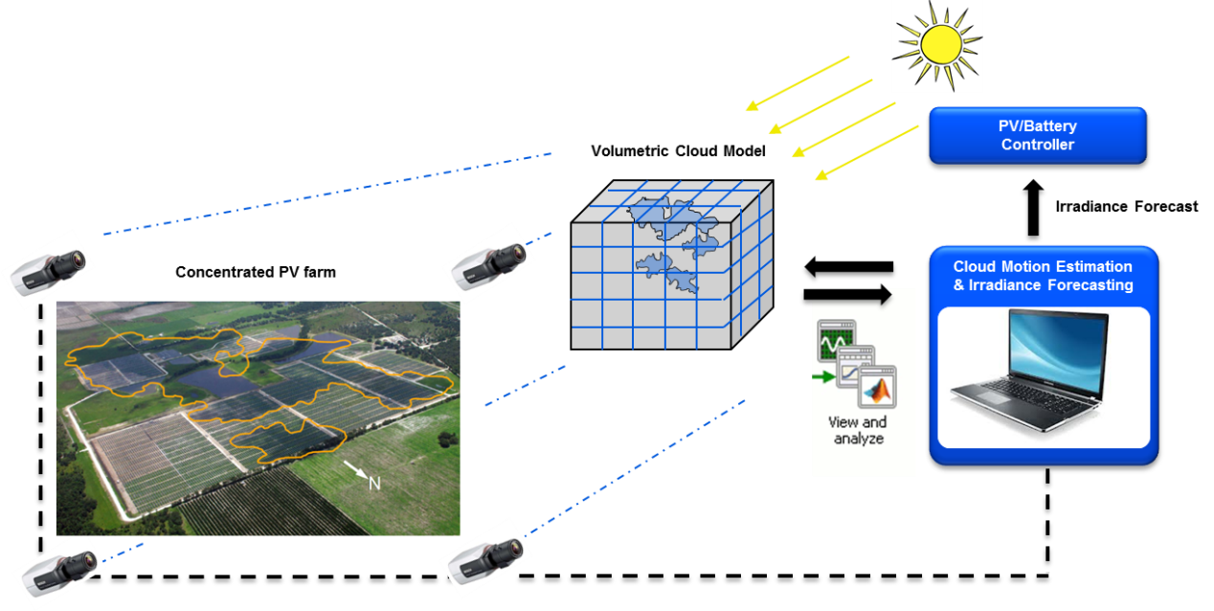

Figure 3 Components of VISMO system prototype

## Project Main Requirements

Help: List all main requirements (functional, quality and business) for the project. For not listed requirements, indicate, how they are documented, e.g. by referring to a mock-up, prototype or a requirements specification document.

The project requirements are listed in detail in the requirements specification document [2].

## Other Alternatives

Help: What other alternatives are available? COTS?

Alternative solution would be to purchase the entire equipment (image acquisition system and processing software) directly from a supplier. A quote has been requested to Yankee Environmental system through its distributor Aero Laser Gmb for a Total Sky Imager (TSI) including its data visualization engine. However, the total cost seems to be extremely high thus representing a limitation for the potential commercialization of the prototype.